Chapter 5

A New World: Aston Park and
The Aston Lower Grounds

Aston Park which has within it not only the Lower Grounds site and the magnificent Aston Hall is without doubt, recreationally speaking, the ‘Jewel’ of Aston Manor’s recreational history. It was the location that provided for if not a unique approach to the provision of recreation at least one that afforded opportunities that very few areas could boast off. Though the site had existed as part of the Aston Hall estate for ‘time immemorial’ it effectively, as a site for organised recreational enjoyment came into being in 1858.
The process by which the area became a place of public recreation might be said to have begun in 1850 when the Hall and approximately 170 acres of the parkland were offered to the Birmingham Corporation for £150,000 in the hope of establishing a public park facility. That this offer was made can perhaps be attributed to two particular factors: a) that the property was extremely expensive to maintain and b) a social movement that was developing in the United Kingdom in regards to the establishing of the public park. Of course it cannot be overlooked that the owners also wished to make a substantial profit.
In order to examine the possibility of obtaining the estate for Birmingham a committee was formed to negotiate with the then proprietors, Messrs. Greenway, Greaves and Whitehead, Bankers of Warwick who had taken control of the property after the last tenant vacated the Hall and the parkland that surrounded it. However, the council did not appear to have had any real inclination to spend public money on the site and indeed did not possess the legal power to buy land for parks provision until an Act of Parliament in 1854, The Birmingham Parks Act gave them the power to purchase for such a cause. However, whilst the Council, in principle was in favour of the purchase they were, in reality concerned about the cost and its effect upon the local rating level. Nevertheless, despite their misgivings the notion of providing a place of public recreation was not, in principle totally rejected.
However, when in 1855 a private purchasing scheme was launched, which almost certainly had the full support of the Council, led by a Mr. Dawson the situation in regards to the future of the estate changed. This campaign which was inaugurated via a meeting in the Birmingham Town Hall Committee Room was the scene of the first real and serious movement towards genuine public ownership. It was during this meeting that Mr. Dawson made the bold and challenging assertion that “Birmingham needed a park worthy of its name” and that it was important that the historic Aston Hall should be saved, to prevent it being: “carted away as so many thousands of old bricks.” He additionally believed that the fine trees that adorned the park should also be preserved to stop them from being “felled for jerry building and road making.” The campaign which was organised under the banner of ‘Save Aston Hall’ had, as its mainstay the wish to approach the general public so that, via donations, the park and hall could be purchased as a public area.
To allow such an ambition to succeed a controlling group was set up, The Public Recreation Society. This body, under the auspice of the Rev’s Miller and Clarke along with Messrs. Dawson, Dale and Langford were set the task of organising the drive towards making Aston Hall and its parkland a place of public recreation. The location, when obtained was to feature, presumably within the confines of the Hall itself as well as the grounds, the provision of:

‘lectures, newspapers and periodicals, vocal and instrumental music, chess, draughts bagatelle, backgammon, bowls, quoits, skittle, tennis, singlestick and gymnastics.’

However, in order to assure respectability it was clearly stated that gambling was to be prohibited and smoking was allowed only within a clearly specified smoking room. In regards to refreshments all alcoholic drinks were to be totally excluded though, in a concession to equality it was agreed that the female could be admitted to the musical entertainments as well as the lectures and readings. Admission was however to be limited to persons who were over the age of eighteen.
The first movement towards raising the finance to purchase was enacted in July of 1856 when a fete was held in the grounds for the benefit of both the scheme and the Queen's and General Hospitals of Birmingham, which produced a profit of some £658, which was democratically evenly split towards the dual targets. Yet despite this effort raising the funds proved difficult, failing to both obtain the necessary finance and public interest. It quickly became apparent to those who had conceived this scheme that their ambitions could not be fulfilled, thus provoking the society to be wound up.
Nevertheless the failure of this initial attempt did not in any way dispirit the ambitions of those who wished to establish a public recreation park in Aston Manor. For, the following year members of the Society, along with other interested parties formed another, more cohesive organising structure, The Aston Park Company to replace the initial society. This new arrangement which was, in fact a limited liability company clearly set out its aspirations from within a memorandum, which stated that it was its ambition:

“To purchase the Park etc with a view to derive a profit from such purchase and thereby to compensate the company for outlay”

and

“With ultimate intention, after providing such compensation to appropriate the Hall and premises to the use of the public thereto, and to apply all profits to the maintenance and improvement of the Hall and premises and not for any pecuniary benefit of the company of shareholders.”

This new administration however was not content simply to rely on ‘profits’ from events, but rather sought to introduce an innovative method of providing the necessary finance. The monies to purchase the site was now to be raised via a multi-tiered share issue to the general public which would then be repurchased from the profits of the various entertainments and refreshments that were to be provided on the site. The aim was thus that the monies raised would allow for a complete transfer of the property to the Corporation for general public use. These shares, classified into three distinct types were to provide the shareholder, in the case of: a) personal admission and to certain other privileges to be hereafter defined but no dividends; b) represented donations to aid the cause and these money to be invested by the trustees to provide other such shares for the same purpose and c) ordinary shares entitling the holder to dividends but with no privileges. Unfortunately once again the aspirations of the company were dashed, the seeming attractiveness of the scheme failing to inspire any popular backing. But, in an effort to boost the campaign a radical proposal was made, to widen the appeal and to invoke a direct plea to the mass of the local population, the working class.
Leading local industrial figures were canvassed and various delegates drawn from their respective workforces were sent to a meeting where the trustees sought out their opinion as to their attitude toward the scheme and whether they would be prepared to co-operate in the attempt to bring the scheme to fruition. The result of this initiative was that in June of 1857, again in the Town Hall, Birmingham, under the chairmanship of Mr. Dawson a meeting was held and after a lengthy discussion a scheme was proposed and after a vote, endorsed. Canvassers were selected and employed and arrangements were made, after the owners of the grounds and Hall, Messrs. Greenway, Greaves and Whitehead gave their permission for another fete to be held on the grounds to raise funds. This event, which was enacted under the auspices of a newly formed Working Men’s Committee was held in the October of the same year and raised the sum of £569 11s 0d, all of which was paid over to the company. Yet, despite the efforts made the amount raised was significantly lower than had been expected and once again the project seemed to be in danger of failure.
However, despite what must have seemed the likely collapse of the project the owners of the Hall and park were again approached and they agreed, after what must have been lengthy discussions to a set period of time within which the trustees would be allowed to raise the necessary capital. Upon a price of £35,000 being set, with a deposit of £3,500 being suggested, a concord was reached that a period of two years was to be allocated within which the remainder was to be paid, in quarterly installments of £4,000. Additionally, in what must be considered as a most generous concession and as an indication of optimism the owners agreed, as a sign of good faith to accept part payment in shares.
Upon this decision another managing committee was set up and Mr. Langford was elected secretary and a directive made that each share should have a value of a Guinea, 2/6d to be paid in instalments on the understanding that, if failure occurred all monies would be returned. Papers were then drawn up detailing the Articles of Association, allowing for the company to become legally the proprietors of the site. Eventually on 12th February, 1858 a final contract was signed, the deposit paid and, the following day the property of Aston Hall and its Grounds was formally purchased. At this meeting a revised version of the Articles were presented which now clearly redefined the previous arrangements in regards to the issue of shares. Now they were defined as follows:

The ‘A’ share was to:
‘admit the Holders to the Park and Hall on all ordinary occasions and on Sundays, Good Fridays, Christmas Days and all legally appointed holidays, but not to entitle to dividends, nor admission on extraordinary fetes nor when the Hall and Park are granted for charitable or public purposes.’

The ‘B’ Share issue would however:

‘not entitle the donors to privileges or profits, but the money given to be vested in trustees for the purposes of ultimately making the Park free.’

The ‘C’ issue would only entitle the holders dividends but not privileges.

As a result of this meeting Mr. Langford became the Share and Donation manager; whilst Mr. O‘Neill was appointed secretary and Mr, H. G. Quilter, Clerk of Works.
The first official meeting of the shareholders eventually took place in March, again in The Birmingham Town Hall where the first report of the company was read out. Within this document, which outlined both the proposals and ambitions for the site was a request from the Working Men’s Committee which clearly stated that it:

“had from an early period in their undertaking a strong feeling upon the necessity of making an extraordinary display at the opening of the Park; and as soon as the success of the movement was placed beyond doubt the working men thought it proper that representation was made to her Most Gracious Majesty of the purposes for which the park and Hall were adapted, and the means by which they were obtained, her Majesty might be pleased to accept an invitation to inaugurate the Peoples park. A deputation was appointed to confer with the Mayor upon the subject and he at once undertook the initiatory steps for laying the subject before her Majesty. The result of these efforts is now known to all; Her Majesty has consented to open the park and your interim managers look upon this as the crowning success of their undertaking.”

It was therefore, with great excitement that, in early 1858 the Committee, shareholders and general population received the news that the Palace had confirmed that the Queen and The Prince Consort had agreed to open the park as a place of public recreation and, in order to fulfil this task would therefore be coming to Aston Manor. The great day soon arrived and, on 15th June, 1858 Aston Manor prepared to welcome The Royal Party.
In the correct presumption that an immense crowd would be at the site to welcome them it was decided that a considerable number of extra policemen would be needed. Because of this many officers from outside the area were required to be drafted in. As a result a number from Staffordshire were requested. However, upon arriving at New Street Station, Birmingham some hours before the Royal party they were ordered to change their customary blue uniform trousers for white ones, due its seems to the fact that the weather had taken a change for the better. As no proper changing facilities were available the officers unfortunately had to find whatever private space was available to comply with the order. That some of them could not could find suitable locations was not enough reason to prevent them from having to obey, so in full public view the change of apparel was completed, which caused, it was said some consternation to the officers themselves and to the members of the public and railway staff. However, after this difficulty was overcome the Staffordshire police contingent, who were allocated to be mounted were apportioned, for their duty a section of the route that stretched from Aston Cross to the entrance to the actual Park. Unfortunately, due to the fact that they were ‘on post’ for a considerable time before the Queen and her Party were due to arrive and that it was rather warm the horses required watering. For one unfortunate officer however, after giving his mount a drink he found himself upon one that was seized with a ‘violent and involuntary fit of coughing.’ This unexpected development was unfortunately accompanied:

“by corresponding and unusually loud reports from the rear, continuing at intervals for some minutes, to the great amusement of the spectators present, but to the intense disgust and great annoyance of the owner, who thereupon mounted and rode away to avoid further observation and remarks.”

However, after what must have seemed a considerable wait for many of the spectators who had turned up early to get a good view, at last, after a cannon shot rang out they knew that Royal visitors had finally arrived in Birmingham. After being greeted by local dignitaries the Royal party were driven in procession through central Birmingham and into Aston Manor itself, passing along streets which were thronged with excited spectators to Aston Hall. However all did not go well. Because of what seems to have been a lack of perception as to the effect of the Queen’s visit there seems to have been inadequate crowd control. Because of the desire to allow as many people as possible to see the Royal visitors far too many had been allowed to congregate along the route. The result was that it quickly became obvious there was a need to ensure safety and, to make sure no one was hurt many people had to be removed. Eventually, to guarantee safety a chain barrier was erected to allow the the Royal party to pass by freely. Unfortunately, due to a heavy handed approach by some members of the visiting London Police, they attempting to physically force the crowd back led to a more serious situation developing, one that seemed to be heading towards a major public disorder. Thankfully, for the sake of the occasion and the welfare of the gathered crowds, with the aid of a more humorous approach ‘accompanied by kind words and persuasion’ from other officers the danger was averted and good order regained. However, the London officers were not forgotten by many in the massed gathering and due to their previous heavy handedness were ‘decried and unfavourably spoken of’ by the throng.

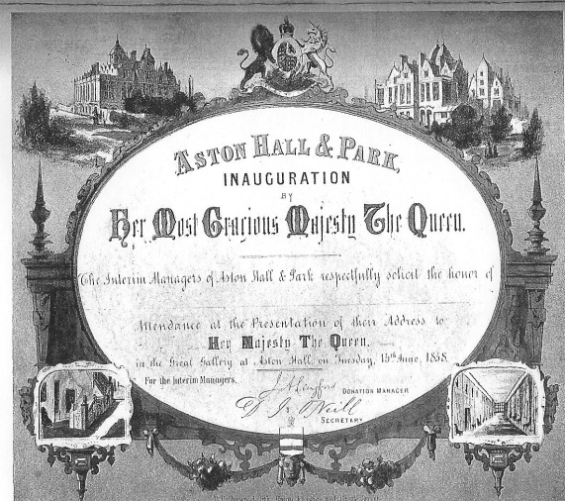

Official Invitation Card to the Royal opening of Aston Hall and Park as a public park.

At last the Royal Party arrived and, after a luncheon which many local dignitaries attended they and Royal guests made their way to The Great Hall and were addressed by Sir Francis E. Scott, who had acted as Interim Manager during the period up to the completion of negotiations. Amongst many references to the arduous path that had been negotiated he stated, conveniently overlooking the fact that the park was not in Birmingham:

“In some towns in your Majesty’s dominions public parks have been wisely provided by wealthy Corporations; in others by the munificence of philanthropic citizens; here, also, we are indebted to private liberality for two places of recreation for the people; but to Birmingham alone has it been given to secure by her own exertions an ancient Park for the physical relaxation - an ancient Hall for the mental cultivation - of her variously employed and laborious population. Your Majesty will, we believe be gratified to learn that Aston Hall and park have been acquired, for the most part by the industry and economy of the people themselves. Of the money required for this purpose a very large proportion has been subscribed by the working classes, a circumstance which we venture to hope that will not be without interest and satisfaction to your Majesty.”

In response the Queen commented:

“I sincerely thank you for your loyal assurances of devoted attachment to my throne and person. The improvement of the moral, intellectual and social condition of my people will always command my earnest attention; and in opening this Hall and Park today I rejoice to have another opportunity of promoting their comfort and innocent recreation.”

Finally, after all the necessary ceremonial speeches had been concluded, The Queen and the entourage left the Great Hall and stepped onto a balcony overlooking the mass of people present. After the cheering had stopped she officially opened the site, by quietly saying to Sir Francis: “I request you will have the kindness to declare that the Park is now open.” After spending a little time with the gathered dignitaries and promising to lend various works of art to the Hall for a proposed exhibition, an offer that was reciprocated by many present it was time for them to leave. After getting into their carriages the Royal Party riding, again in procession left Aston Hall to travel the short distance, passing still massed crowds to a recently erected temporary railway station which had been built for their sole use.
As a result of the visit and the fulfilled promises by both the Queen and various dignitaries of the area to supply artefacts an exhibition was, some little time later organised. Within an especially constructed pavilion adjoining the Hall items of painting, sculpture, porcelain, pottery, carving, enamelling; ancient and modern metalwork, furniture and armour was exhibited. Indeed so comprehensive was this that it drew even the attention of the London press. Describing it to be, after The Great Exhibition and a similar function that had been held in Manchester: “one of the greatest held outside of the Metropolis”.

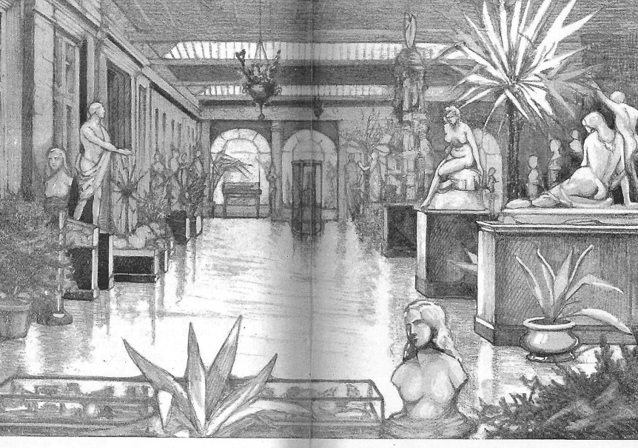
A scene of the exhibition Hall used to display the works of art lent to celebrate the Opening
of Aston Hall and Park as public amenities.1858.

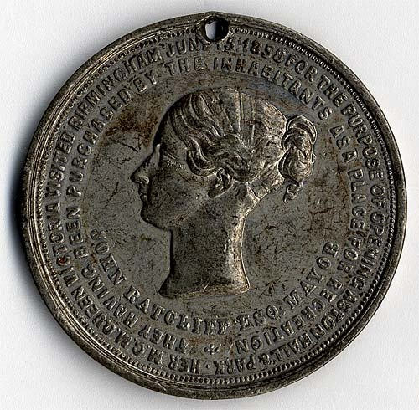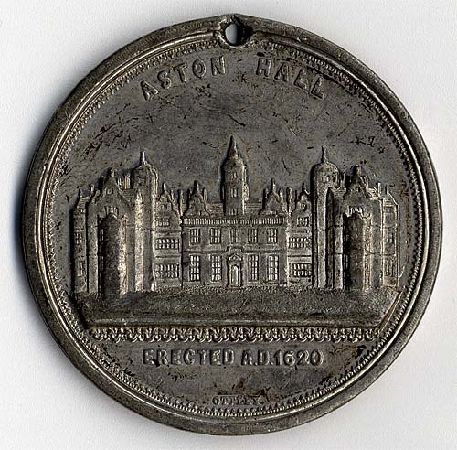

The Aston Hall Medal. Manufactured in Birmingham and issued in 1858 to celebrate the opening of Aston Hall and its parkland by Queen Victoria The obverse features the bust of Queen Victoria facing left and the inscription 'Her M.G.M. Queen Victoria visited Birmingham, June 15, 1858 for the purpose of opening Aston Hall and Park, they having been purchased by the inhabitants as a place for recreation/John Ratcliff Esq. Mayor. The reverse features Aston Hall with the date it was built underneath. The hole is not part of the design .

Such was the excitement generated by the visit that one person, titling himself as “His Worship’s Obedient Servant ‘Quiz’” provided what appears to be an eulogy of thanks in regards to Sir John Ratcliff, The Mayor of Birmingham whom the author thought responsible for the event. This work, a poem of considerable length, had, as its aim a description of the great day. Though it is far too long to reproduce here its tone and message can certainly be ascertained via the following selected passages:

But who shall well describe the day,
In laboured prose or kindling lay,
When to our town the myriads came,
To welcome England’s Royal Dame?
For weeks and months the talk has been,
Th’ intended visit of the Queen,
Each house and pile with rival pride,
Assum’d its fairest - best outside,
Flags, banners, stars were in request,
In colours gay the shops were drest,
While platforms rear’d their hills of wood,
And stood where nothing else had stood,
In every window there was seen,
Some emblem fair to meet the Queen.
All night the village around,
No kind, refreshing rest was found,
In feverish, anxious state they lay,
Lest they should sleep into the day,
And now upon the roads they wend,
Where’er into the towns they tend,
Carts, gigs and carriages were seen,
All pressing on to meet the Queen,
Pedestrians too, both old and young,
And all well dressed made up the throng.

And here beside the noble pile,
That brilliant cortege halts awhile,
Mid further tokens of delight,
The Queen and Royal suite alight,
To view the Hall’s interior graces,
Enhanc’d still more by smiling faces,
When moving with it’s Royal load,
The carriage reached the Aston Road,
Wafted in sweetness on the gale,
Their Queen, ten thousand voices hail,
In treble notes the strain prolong,
Til thrice ten thousand catch the song.

How grand a picture for the world,
How great the moral here unfurl’d,
O! waft it on the gladdening breeze,
Tell it ahwart the gladdening seas,
Tell it where the despots rule with scorn,
Tell it where slaves for freedom mourn,
When industry may thus achieve,
More than our fathers might believe,
Break down the power of feudal pride,
And open the gates so long denied,
And call a willing Queen to bless,
With fostering hand the great success.

On either side a waiting host,
Had fixed themselves in seats of cost,
Content to see the Queen retire,
To see the Queen - their one desire,
E’en to the Aston Railway Post,
Was gathering seen the lingering host,
As if to catch but the farewell,
Would, in their nurturing memories dwell.

Yet despite the euphoria that the opening of the site provided the share scheme that underpinned the project was far from successful, the public both failing to purchase shares or even donate. For many ‘A’ shareholders the grievance was that the benefits that they offered were in fact, illusionary. Many complaints were received, complaints that led to a proposal that essentially redefined the benefits allied to the holding of this grade of share. Individuals who held this type would now be entitled, along with a wife and children under twelve to free admission on days when no fete or public entertainment was being held and to free admission on all Bank Holidays. Additionally it offered, as a further inducement the opportunity, for half price entry exhibitions, flower shows, Easter and Christmas festivities and other entertainments. The effect was that once the full price of the share had been met then the holder had the benefit of free entry for as long as the park was in existence.
Nevertheless, despite these innovations the period following resulted in a trading loss. Yet enthusiasm remained strong and the project continued and on 20th July, 1859 a ‘Colossal Fete’ was presented. Despite the fact that this appears to have been successful it did not solve the problem. Faced with what must have seemed to many an impending financial failure, in 1860 a meeting was demanded by shareholders insisting on an explanation as to why the scheme was struggling. The result was that an investigative committee was set up, not only to examine the running of the site but also, presumably to apportion, if any, blame. Under the chairmanship of a Mr. Thomas Willson and six other committee members their report was, paradoxically, both damming and hopeful.
In what was a full and concise account it was pointed out that the fete known as the Queens Fete, the presentation allied to the opening by Queen Victoria had made a loss of some £1,424 13s 4d, having incurred expenses of some £3,326 16s 8d but only managing receipts of £1,900 13s 4d. In an explanation the report pointed to, amongst other items to over £1,000 being paid to builders for the erection of stands and of £70 and £50 being paid respectively to Messrs Pashby and Instone for the permission to construct a straight road over their land to prevent the Royal Party using the ordinary road when they eventually left the parkland. It was also pointed out that despite the fact that the Royal luncheon was actually paid for by Birmingham, the company still incurred substantial expense. There was, it was stated over £54 paid to a Mr. Phillips for wine, Claret costing £5 and Sherry and Port at £3 6d per dozen bottles, the total wine consumed being some 157 bottles. Additionally it was noted with more than an element of surprise that, by order of a Mr. Bloxham, one of the controlling committee: ‘beef, ham, ale and stout for 100 policemen’ was also provided, costing the not inconsiderable sum of £116 1s 0d.
Criticism was also levelled at the general way the company conducted its business, drawing on evidence from actual members of staff. A Mary Spencer, for example who was employed in the capacity of assisting in the cutting of the multitude of sandwiches required stated:

“members of the Committee came into the cutting room, and supplied themselves with sandwiches. I thought this right at the time, but have since been of a different opinion. I heard Mr. Garratt complain that the amount put down as the take on one occasion was not enough. Members of the Committee and their families came into the cutting room and were supplied with sandwiches and I was sent to fetch ale for them. None of the ale that I have been sent for was paid for.”

Another, Miss Hayes, whose function was to assist in the refreshment rooms though not being able to make any general observations in regards to the ‘smallness of profit’ was nevertheless able to make comment that she:

“Never saw anything going on. Managers have had glasses of ale without payment. Mr. Quilter used to come with a bag for the money. Never knew what it amounted to. Always considered that the Committee had a right to be served with whatever they asked for, whether paid or not. Looked upon Mr. Quilter as her master. Committee used to have spirits to take home in bottles, but it was supplied from the cellar and probably paid for. There was no check on my honesty, might have kept money had I chosen.”

The conclusion was clear, that the accounts were substantially correct. However the comments of the investigating committee must have made many individuals who were involved in the running of the event extremely uncomfortable, in that it was found that the:

“management has been in nearly every respect bad, but allowance has to be made for the novelty and extent of the undertaking, and for the fact that, as a rule, many of the most competent men on the board of direction have abstained from taking an active part in the undertaking.”

“The purchase was made at a price long beyond the market value of the Property.”

“The managers at the outset expended upon alterations, new
buildings and decorations nearly half the money that was subscribed
for the purpose of buying the estate.”

“The Managers have hitherto shown themselves utterly incompetent to conduct the troublesome and precarious business into which they have embarked”.

“From the circumstances over which the company had no
control, the Queen’s visit was, financially speaking, a lamentable
failure.”

The report also noted that, during the two years that Mr. Quilter had been in charge the following amounts of money had been expended:

Refreshment Room wages etc £426 19s 4d
Refreshment Room expenses £132 7s 9d
Refreshment Petty Cash purchases £312 13s 0d
Exhibition and music £1,011 8s 6d
Park Wages £497 19s 0d
Road and Garden Alternations £360 11s 0d
Lower Grounds Wages and expenses £73 17s 1d
Fete and Revel expenses £473 0s 4d
Alterations and repairs £429 7s 4d
Wages and sundries £482 11s 4d
Materials £23 2s 3d

However, despite what seem dismal financial figures the reports concluded that under “skilful and economic administration the park may be pronounced capable of earning a net sum of about £2,500 a year.” Unfortunately the company also faced another serious problem, one that if not resolved threatened to involve, as the investigating committee noted, a possible eviction order which, if served would have allowed the owners of the Hall and grounds to reclaim the property.
Yet, perhaps due to the somewhat optimistic outlook that the investigating committee had concluded their report and the very likelihood that the owners would have great difficulty in ridding themselves of the estate the project was allowed to continue. Optimistically, by 1861 a hopeful atmosphere appears to have emerged which resulted in the tactic of again holding Fete’s to raise the necessary finance. It was therefore with great confidence, and it must be suspected no little expense that The Great Blondin was hired for a two day fete and made his appearance on 8th and 9th June. It would seem that this time that the events had been successful. The takings at the gate allied to that raised by the sale of refreshments had ensued enough money had been taken so as to allow for a payment to be made to the owners and towards the interest on monies owned. Buoyed by the success of Blondin’s appearances the management, some three months later again booked the intrepid performer. In this performance he carried, as was his style of presentation a man on his shoulders whilst walking the tightrope, this feat ending what was a full hours performance. Unfortunately the arena within the park which was to be location for his act was not adequate enough to allow in all those who wished to see him. The result was that, in the words of The London Times:

“there was a tremendous crush outside the entrance, which the staff of policemen were utterly inadequate to quell. A mob of ‘roughs’ attempted to force a passage through the turnstiles at the gates just as it was growing dark and being repulsed by the police, who were mounted, they broke down the palings and fences and set fire to them, and, arming themselves with stones and bludgeons, commenced at a violent attack upon the police.”

The situation immediately became one that the local police could not control. It was therefore in response to the situation that the officer in charge, a Superintendent Legget arranged via the use of both train and omnibus the support of further officers to regain control. As a result seven of the leading rioters were arrested and several police officers were seriously injured. Yet, despite this grave and undoubtedly embarrassing incident it seems that the event was, at least a financial success.
Despite this discomforting episode the Birmingham council appear to have chosen to retain a positive attitude to the project and continued to back the use of the amenity to such an extent that they arranged, within the actual Hall itself a grand Christmas festivity. Given the title of ‘The Twelve Days of Christmas’ it was, as the name suggests held over the traditional twelve days of the festive season, a celebration of not only Christmas but of the site within which it was held, Aston Hall. For, what must be considered a very reasonable entrance fee, of 1d, this being the cost of the programme which would entitle access the customer was able to enjoy what clearly was a most varied and diverse schedule. Not only were Father Christmas and his children present but also the traditional Yule Log, along with a roasting Boars Head and Wassail Bowl. Apart from the obvious opportunities to eat, drink and be merry there was also the chance to cavort to the well known Pountney’s Quadrille Band, this attraction being available from the early evening to 11.30 p.m., when the day’s celebrations officially were ended with ‘God Save The Queen.’ Of course it has to be recognised that those who attended the function were not likely to have come from the working class of the area. It would seem certainly reasonable to believe that those who attended were from the upper echelons of local society.
Additionally there was also entertainment which played due reference to the history of the venue, Sir Thomas Holte and his wife The Lady Mabel making an entrance, as did their his son Edward who was portrayed as celebrating his coming of age. Accompanying these were, at various times ‘Morrice’ dancing and ‘Sailors Dance’ by the twelve children, presumably these representing the days of the festivities along with the star guest Father Christmas. It must have been hoped that when these ingredients were added together, an atmosphere would have been created that provided for festival happiness, and of course profit through the sale of refreshments!! For those attempting to raise finance for the purchase of the site it was hoped that, after necessary costs had been deducted enough would remain to make a positive contribution. Whether anything found its way into the coffers is not known, though there can be little doubt that any positive publicity would certainly have been most welcome. It seems however that the following two years trading saw little advance, resulting in no contributions being made to the sum owed which would have then allowed for a purchase. It was however in July of 1863 that perhaps the final ‘nail in the coffin’ for the scheme was sustained. During a fête arranged by the Foresters, a Masonic style organisation, a Mrs. Selina Powell, the ‘Female Blondin’ died, after falling thirty foot whilst performing a rope walking act.

It was reported that she made her grand appearance shortly before 7 o’clock in the evening. It was said afterwards that the rope on which she would perform was so badly worn that an official on the site said that he would: “not allow a dog to be tied up with it.” However, this rope was tied between two trees, this being done under the supervision of the performer’s husband. Once all had been checked she climbed upon a platform and, to the cheers of the crowd who had gathered to watch her husband passed her a balancing pole and chalked her boots ready for the show. As a band played she stepped onto the rope. She proceeded to walk about half its length and then performed several feats including kneeling and standing upon one leg. After receiving a good round of applause from the large audience present she then had a bag placed over her head, having first been blindfolded. She then again moved onto the rope, holding the pole for balance. Suddenly, without warning, after she had taken a few steps the rope broke and the unfortunate performer fell to her untimely death. Though medical facilities were quickly at hand nothing could be done to save her. Tragically, as was discovered afterwards the lady was heavily pregnant. Yet, despite the appalling ending of her life the fete was allowed to continue, being concluded at midnight with a display of fireworks. It would seem that a committee of the Forester’s had held a meeting after the accident to discuss whether it was appropriate to continue but had decided that ‘the show must go on.’ The response to this decision from much of the press was swift, damaging and widespread. In regards to the festivities being allowed to continue even The New York Times, taking the story from The London Herald stated:

“The managers of the Aston Park, we understand, had no control over the entertainment; but, there must have been some one with authority enough to put an end to a scene which was a bitter and heartless mockery of death. The prolongation of the entertainment - the drinking, the dancing, the music, the feasting and revelry - all going on, within sight and hearing of the very room where that poor woman lay stiffening in death, adds the last touch to the horror of the original catastrophe. The poor woman who met her death as above described appears to have styled herself the Female Blondin after the catastrophe that happened to the original at Highbury-barn. She is said to have been a native of Birmingham.”

The incident provoked considerable disquiet, and, as a result the Mayor of Birmingham Council, Mr. C. Sturge received the following letter from the Palace:

“The Queen has commanded me to express to you the pain with which her Majesty has read the account of a fatal accident which has occurred during a fete at Aston Park, at Birmingham. Her Majesty cannot refrain from making known through you her personal feelings of horror that one of her subjects, a female should have been sacrificed to the gratification of the demoralizing taste unfortunately prevalent for exhibitions attended with the greatest danger to the performers. Were any proof wanting that such exhibitions are demoralizing, I am commanded to remark that it would be at once found in the decision arrived as to continue the festivities, the hilarity, and the sports of the occasion after an event so melancholy. The Queen trusts that you, in common with the rest of the towns people of Birmingham, will use your influence to prevent in future the degradation of such exhibitions at the Park which was gladly opened by her Majesty and the beloved Prince Consort, in the hope that it would be made serviceable for the healthy exercise and rational recreation of the people.”

This rebuke, followed shortly afterwards by an equally scathing report from the Secretary of State, a Mr. H. Waddington provoked the Mayor, through the council to approach the Lord Lieutenant of Warwickshire, requesting £8,000 towards the monies that would be required to take the property into council ownership. That this request was made can perhaps be attributed to the fact that Birmingham was either unwilling or unable to contribute financially towards the scheme a stance that may have had at its core the fact that Aston Manor was actually not part of the town.
This request, however, was firmly rejected but, after a second stinging letter from The Palace the matter was finally resolved, when, following a failed bid by the Mayor, ‘in council’ to raise the sum required a private subscription was organised, thirteen private individuals donating a sum of some £7,000. This amount added to that which had already been paid by the Aston Park Company was thus offered to Birmingham if they would pay the remainder and end the sorry saga. At last the council relented and on 2nd February 1864 they provided, it might be presumed reluctantly, a figure in the region of £20,000 and became perhaps the unwilling proprietors. Upon this payment, on 7th August, 1864 The Aston Park Company was finally wound up, allowing for a formal act of purchase to be completed on 12th September, 1864 thus bestowing the land into the care and control of the Town of Birmingham. The honour of opening the site as a Free Park this time fell to the Mayor of Birmingham, W. Halliday, who celebrated the occasion with a banquet in the Great Gallery, no doubt with a greater eye to cost than a previous opening function!
Earlier, in May of the same year The Aston Park Company had held their final meeting which was the scene of presentations to those individuals whose valuable service to the company had been recorded. Amongst those presented with mementoes was Mr. J. A. Langford who received, it is recorded a ‘handsome gold watch, a copy of Knights Pictorial Shakespeare and in seven volumes Robert Ball’s ‘Golden Leaves.’ Additionally, as a memoriam to those individuals who had contributed so much to the cause and who otherwise would have gone unrecorded there was placed a plaque within the main entrance to Aston Hall. Perhaps not surprisingly given the endemic social divisions present within society at this time the organisers of this event overlooked or more likely simply chose to ignore the immense contribution that had been made by the many working class individuals to the success of the scheme. Their contribution included vitally, not only supporting the scheme when requested via the purchasing of the various shares that were available but also the not inconsequential act of relinquishing them, in some cases voluntarily and without profit when such an action was considered necessary to finally attain the ambition of the scheme.
However, it would seem that Birmingham Council once again decided to follow its historic path in refusing to become totally financially involved in the maintaining of the park. It took the stance that the expenditure involved needed to be substantially reduced before they could actively feel obliged to become masters of the situation. As a result it was decided to apportion a substantial part of the parkland, the area known locally as The Lower Grounds into private ownership and control. This decision thus led to this part of the grounds coming under the control of Mr. Quilter, firstly as manager under an open ended lease arrangement and then finally as a binding lease holder, a decision that had immense repercussions for the advance of recreation in the area.
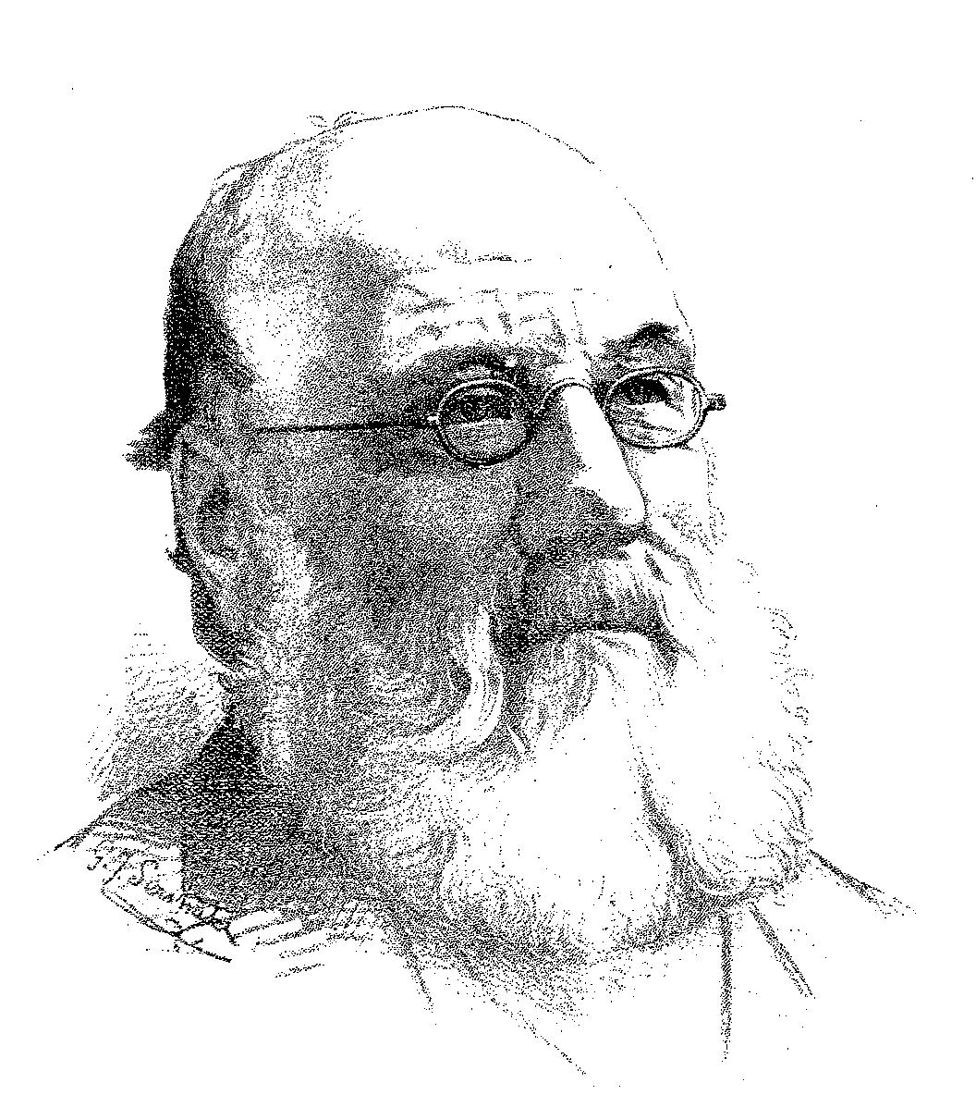
Mr. H. G. Quilter 1825 - 1893

This act, which was, in effect a privatisation of a substantial part of the park was however bitterly attacked by many individuals, including a Mr. D. J. O’Neill who thought that the portion of the park known as The Lower Grounds was:

“now irrevocably lost to the people of Birmingham, through the stupidity of the Town Council. Enthusiastic workers in social matter cry out: ‘Let us have the old English sports and games as on the village green and such like.’ Why, the present Corporation of Birmingham will not allow such things as a dance in the parks of which they are the custodians! The young folk may roam about listless, aimless, hot and thirsty in summer, cold and wet in Autumn and Winter. They can go the nearest pub - not to The Lower Ground.”

Mr. Quilter, the first manager of the Lower Ground site, was not however a local man, but was in fact a ‘Cockney’ having been born within the sounds of Bow Bells, London. Orphaned as a child he worked first in the drapery and then the grocery trades. However, in 1842, he chose to move to Birmingham, having sought and obtained a position with a Mr. Philpott who owned a general grocers business in New Street. He seems to have been employed by this company for approximately four year after which time he decided to open his own general grocers business. Despite seemingly being very successful, he yearned for a more vigorous, outdoor life and, in search of this he became associated with a local builder, drawing up plans and specifications for local constructions. However when the scheme for the purchase of Aston Hall and Park was initiated he saw his opportunity and threw himself wholeheartedly into its support, gaining eventually, as it has already been stated the position of firstly manager and then leaseholder. There can be little doubt as to the enthusiasm of this gentleman as he can be recognised as being not only one of the major driving forces behind the notion of a publicly owned Aston Park, but also in regards to the development of recreation in Aston Manor itself. Perhaps his attitude to his new home can be best surmised when a statement he made is recounted:

“The natural beauty of the Manor affords him a remarkable contrast to the November appearance of Doncaster and the dreary aspect of Bordesley on a bleak February day.”

At the time of the demise of The Aston Park Company the extent of the Aston Lower Grounds was such that it stretched from The Holte Tavern to Witton Cross and between Trinity Road and Witton Lane, the site described, in 1871 in the Post Office Directory of Birmingham as being a:

‘beautiful pleasure garden’ containing ‘cricket grounds, two beautiful lakes, covering five acres for fishing and boating.’

It appears that right from its introduction Mr. Quilter’s site proved popular, many attractions being presented that often drew in considerable crowds. Indeed, in 1871 some 127,370 visits were made, indicating that some 72,575 individual entrances were recorded as having been made to the park, the actual Aston Hall and the museum which the Birmingham Council had installed within its walls.
At the beginning of Mr. Quilter’s tenure two of the earliest attractions that were provided were a Roller Skating Rink and an Aquarium. Though the roller skate is first recorded as having been invented by a John Joseph Merlin in 1760, it was the introduction in 1857 of huge public rinks in the Floral Hall and the Strand of London that did much to inspire the pastimes popularity in the United Kingdom. This facility which opened on The Lower Grounds on May Day, 1875 was described as being 300 foot in length and 80 foot wide and being three times as large as the only comparable rink in the area, this being in Moseley, Birmingham. It was covered in asphalt and was advertised throughout the period as having a ‘most beautifully smooth surface from which not a particle of dust arises’. As an added attraction for the customer a local musician Mr. Pountley along with his band were engaged to provide accompanying music. The facility, open morning, afternoon and evenings throughout the year, weather permitting, charged an admission price of 6d. If however, skates were required a further 6d would allow the individual to loan a pair for a session. The attractions of the facility were, according to the proprietor in a pamphlet designed to advertise its availability and desirability were almost romantically put when it was stated:

“Henceforth anybody may be idle and rich with impunity, for here is work ready cut out which will give us a zest to all the seven meals and a sweet a sleep after them, as would be earned by the exploits of a hero, the thought of a philosopher or the manual labour of a workman. There is no strength required, no natural talent, no long course of application - only grace and dexterity, readiness of balance and taste in dress, which are the innate property and birthright of all in society.”

However, despite the fact that the attraction was commercially inspired the management was always mindful of its social obligation in regards to respectability and good behaviour. In a clear statement of intent that this attraction, along with the rest of the park was a place of reputable recreation the management laid down strict rules and regulations as to modes of behaviour.

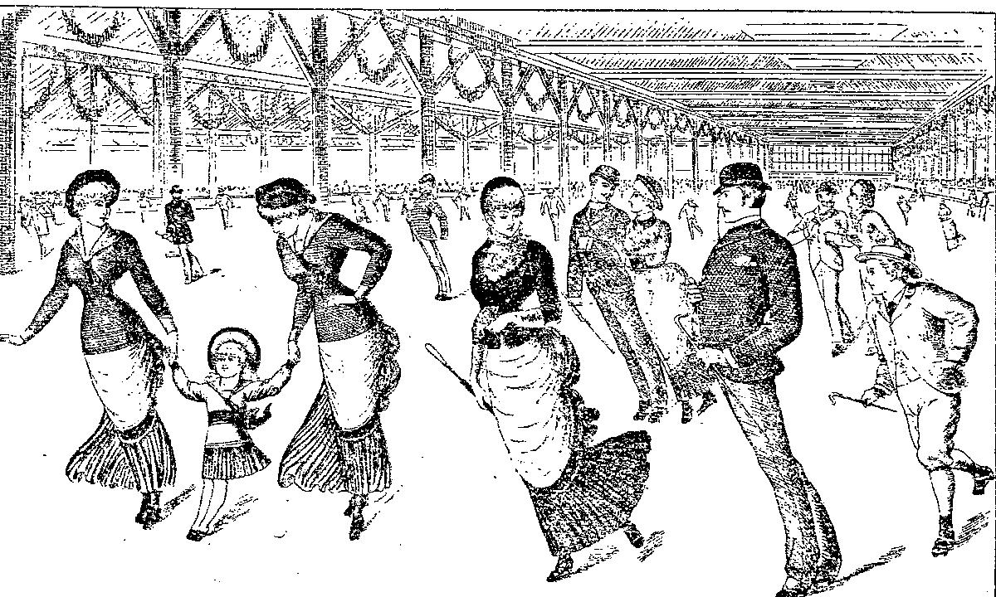

Scene depicting Skating on The Aston Lower Grounds Rink.
This portrayal reflects the years around 1886.

They included guidelines on dress, no stick or cane to be carried and, as the illustration shows a requirement to be of a smart appearance; that all skating was to be done in a uniform direction, to avoid presumably collisions and injuries; care to be taken never to interfere with other skaters and, in a vein of gentlemanly conduct the unaccompanied male was asked not to impede other gentleman who were with ladies or those ladies who were themselves solitary. It could be understood that this facility was one that was aimed at both sexes, the inclusion of the female allowing her what must be considered a rare opportunity for equality. Skating was, as stated by Mr. Quilter a recreation where:

“healthy and invigorating exercise can be indulged in without the annoyance and danger attending skating on ice, which in this country is so uncertain.”

The facility certainly met with the approval of the local press. All of them enthused about the enjoyments and benefits that the rink could provide for its users. Not only could it be considered to be attractive in its own rights but additionally, according to The Birmingham and Aston Chronicle it benefited from the attached winter garden from which Mr. Pountney’s band played, filling the air with “charming music” to which the user was entitled to free of admission. There was little doubt this same newspaper concluded that despite the potential for abuse, for the female if the:

“exercise is adopted with moderation, rinking tends to greatly improved the health and strengthen the muscles. The art of skating is easily acquired and the ladies, especially show great aptitude in learning it. Were it not for them, indeed the rinks would lose a great deal of their attractiveness; but fortunately the ladies are fully alive to the advantages of rinking and are not likely to for sale an occupation so thoroughly beneficial to their physical welfare. To them, more perhaps more than men rinking, on account of the excellent exercise it give to most the muscles of the body - exercises not to obtained by any other exertion - must be productive of the best results.”

In regards to the other attraction at the time, the Fresh Water and Marine Aquarium, opening on 10th July, 1879, the entry fee was initially high, being set at 1/-, this perhaps reflecting not only the cost of stocking the amenity but also the expense that was incurred in building it. This facility which was constructed in red, black and white bricks with white columns with capitals was designed by a Mr. Naden. In regards to the most basic item of the amenity its water this was provided by Messrs Southall Brothers and Barclay who, as chemists manufactured it for the amenity, certainly saving many hundreds of pounds when compared to having it taken from the sea and transported to Aston, some 300,000 gallons being required to stock the tanks. This amenity may well have been introduced to combat another but smaller aquatic attraction that was located in the Crystal Palace garden at nearby Sutton Coldfield. Additionally there was also another water-based feature in Birmingham but here, it was less of a competitive threat as more a curiosity in that it was an "Aquarium Bar," being located at the establishment of a Mr. Bailey in Moor Street.
The attraction can be imagined to have been most impressive in size, being some 400 foot in length and 60 foot wide, expanding to 85 foot in the middle containing nineteen large tanks each some fifteen to twenty foot long, some seven foot broad and five foot in height, all aligned along one side of the building. Also within the complex there were a great number of what were described as ‘smaller tanks containing pure water’ which were used for fish hatching and freshwater varieties. Amongst the species on display within the freshwater tanks were Pike, Perch, Tench and The Lesser Common Dog Fish!! In regards to the marine animals it would seem that the management went in for the rather spectacular, displaying seals and other large marine animals, including fine examples of the ‘Devil Fish’, the Octopus (shades of Moby Dick perhaps). The management however, always mindful of providing an attractive image as possible to its presentations were particularly inventive in regards to this facility. For, it is recorded that over each large tank there was placed a four foot in diameter image, in stained glass, each providing for a Shakespearian motto directly relating to the exhibit. Additionally between the tanks were columns enhanced with Milton tiles. Indeed even the floor had not been overlooked, this too being made up of Milton tiles. Given the fact that the whole edifice was electrically powered allowed it to be granted a not inaccurate description:

“Indeed the lavishness, perfect good taste and yet subdued character of all the decorations, is a conspicuous feature in this the finest and most complete aquarium yet built or conceived.”
Yet rather surprisingly, this amenity though initially popular did not seem to retain interest. Despite the larger tanks exhibiting as already alluded to ‘rare and choice specimens of marine animals,’ as the advertisement below indicates it seems that after the initial surge interest waned. In an effort, to promote the site and by inference the aquarium, the Lower Grounds company negotiated what seems to have been a very attractive package deal with the railway company to provide a special all-inclusive price, which included entry to not only the grounds but this facility: New Street or Monument Lane to either Witton or Aston - First Class 1/4d, Third Class 1s. Yet even this does not seem to have provided enough interest. For all the efforts made it was finally closed in 1886.

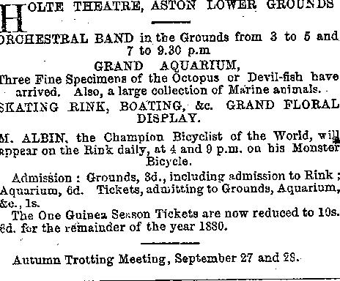
Taken from the Dart, 18th September, 1880

Despite the fact that the site in general terms appears to have been popular and was able to attract quite reasonable attendances it had became clear to the management that, if it was to expand and be able to provide ever more attractive features additional capital was required. Yet, again it would seem that Birmingham, did not wish to become further financially entangled and that Mr. Quilter, as an individual was not in a position to invest to the level needed. The result was that in 1878 a new controlling company was proposed, The Aston Lower Grounds Company. Mr. Quilter was thus offered what might be considered a very attractive deal within which he relinquished his control of the ground, for a sum believed to have been around £45,000, this being paid both in shares and instalment payments. He was additionally offered, and accepted the position of Managing Director of the new organisation. So in 1878 the new company took over. The immediate effect of this change of direction was that the site was now, seemingly to have been placed in such a financial position so as to be able to offer even more attractive presentations, and presumably make a more substantial profit. Indeed it would seem that the aim was to make the Lower Grounds which, in modern parlance might be described as a ‘leisure centre’.
The Lower Grounds at this time covered an area of a little over thirty one acres, enjoying a position that was some two miles from the centre of Birmingham. It was serviced by a good public transport system including not only a railway but also a tramway service, this being run by the Birmingham and Aston Tramway Company.

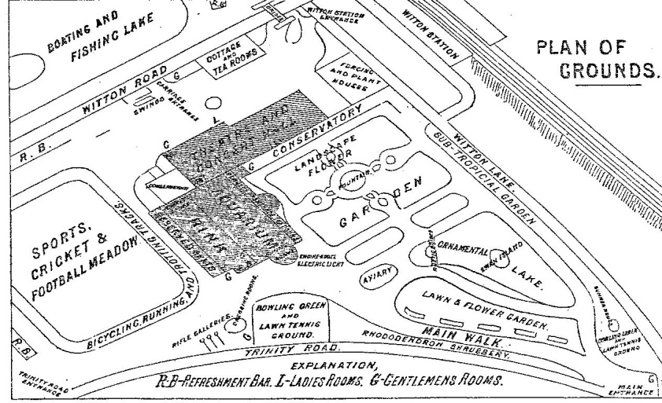
Aston Lower Grounds as at 1884

The development can now be understood to have begun to move away from the principals that underlined its original conception. Though formerly aimed at being a means by which a moral standpoint could be stated, a respectable recreational facility which would not only inspire the less respectable (these obviously believed to be, in general terms the mass of the working class) but also stand comparison with other locations such as The Vauxhall Gardens, London and the Bingley and Curzon Halls of Birmingham, the site now was in essence ‘all things to all men.’ The Grounds was thus, in a sense an amalgamation of the garden and exhibition concept, one that was aimed at providing a level of recreational opportunity comparable to anywhere in the country. However, on many occasions its presentations certainly reflected a more ‘middle class ethos’ which perhaps intentionally barred the masses. A perfect example of this being that when the great W. G. Grace made his appearances they were appointed to a weekday, a day when most of the population of Aston Manor and adjoining districts would have been at labour.
Whatever changes were planned or envisaged there can be little doubt that the pride of the site was The Theatre/Great Hall. Opened in 1878 it was within this arena that many of the more spectacular theatre and musical presentations were enacted, some of which, as will be indicated later were sometimes of considerable scope. That it was able to provide large scale presentations was entirely due to its sheer size. Being some two hundred and twenty foot in length and ninety foot wide, it was elegantly gilded and decorated. This theatre space had, on three side galleries with the remaining end harbouring a stage and was described in 1887 as:

‘Galleries run along either side, and at one end supported by massive iron columns, having ornamented shafts and floriated caps. The ceiling, panelled with wood is exceedingly pretty. At one end is a fine stage, with a handsome proscenium, orchestra and all requisites for musical or dramatic representations. Dormer windows and a long line of circular lights with large and handsome circles in the gables, filled in with tinted glass afford light to the building. Gas is also laid on and complete arrangements exist for using the electric light whenever required. For the latter purpose large electric lamps are hung throughout the hall.’

Perhaps most imaginatively a section of the floor was constructed to be removable, it was stated in order that equestrian events could be held. Despite this rather ingenious idea it appears that no such events were ever held.
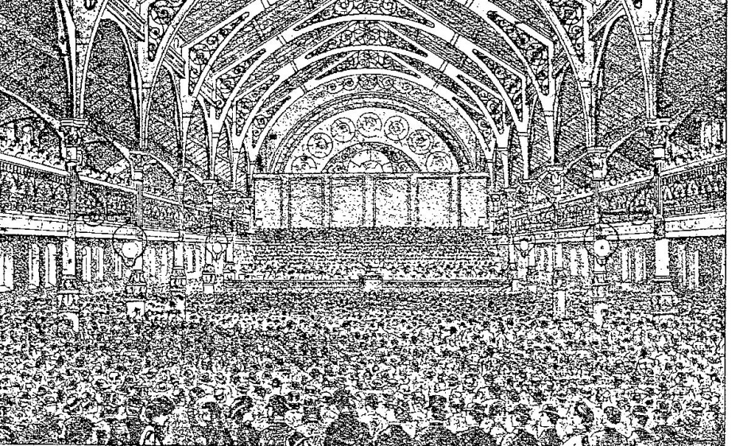

The Theatre and Grand Hall, as at 1887

Next to this was a menagerie which had replaced the failed aquarium, a victim, in 1886 of the drive to further enhance the site. This facility which was stated to have been especially designed by a Birmingham architect Mr. Thomas Naden, the same individual who had designed the aquarium, might suggest that the original aquatic site had been modified for a new purpose. Further evidence of this can perhaps be gleaned when it is considered that this new construction was made of red, black and white bricks ‘interspersed with white stone columns,’ a description very close to that provided for the aquarium. Also, as can be seen in the illustration of the facility, above the cages there appears to be circular decorations, very reminiscent of the Shakespearian elements mentioned previously.
However, whatever the source of this attraction there can be little doubt that it contained, by any standard, for a provincial recreational site a breathtaking array of animals. Not only could the visitor view such as the Bengal Tiger, Panther, Jaguar, Puma, Lion but also a Polar Bear Pit, presumably with the animal in it. Also at this time there was introduced, what was mysteriously advertised as a ‘Cavern of Mysteries, which intriguingly was ‘panelled’ by a Mr. L. Halt. Allied to the fact that such as the Elephant, Brown Bear and Camel could also been seen along with various species of Kangaroo, the latter animal being housed in a specially constructed Kangaroo House must have provided, for the visitor, a quite amazing experience.

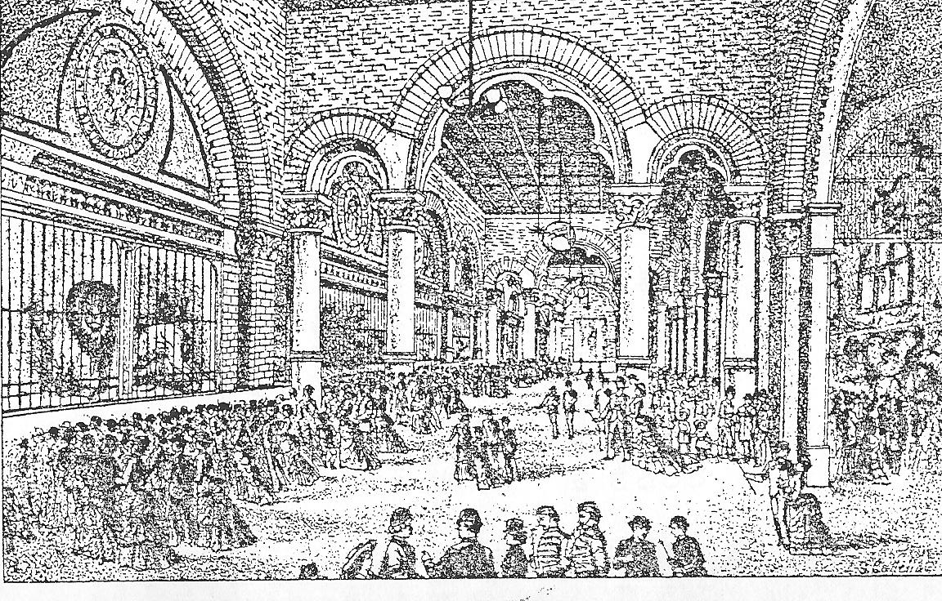
The Menagerie, Aston Lower Grounds, 1887.

Yet for those who desired a slightly less exciting focus there was however a Conservatory, which included not only a wide variety of flora but also access to a promenade shaded by ‘mature forest trees.’ This attraction, which was heated via hot pipes allowed those with an interest to view such examples of exotic plants and trees as Acacia and Eucalyptus. The visitor passing through this attraction could not only gain access to the Theatre but also to a ‘Camera Obscura’, where for a:

‘trifling charge the outside world may be seen in miniature, reflected to the very life, showing every detail coloured in natural hues. On high days and holidays when the grounds are crowded, the scene is animated beyond description and furnishes a kaleidoscopic picture with changes every moment.’

Additionally, and it is doubtful if many locations could boast of a similar facility, was a site for Tobogganing. Described as being of a similar nature to that enjoyed by those of Canada, it appears to have been a slide-like construction. In addition there was also a ‘Monkey House and Foreign Aviary’ containing many species of animals and bird life. Here the visitor would have the opportunity to see such as the Rhesus, Mandril, and Macaque monkeys and from within the ornithological world Cockatoos, Macaws, and Parakets. Within the complex there was available a further cage area which had within it a wide variety of smaller birds, such as the Java Sparrow, Finches of all colours and Weavers. Also present was the Minor Bird. This particular animal, coming from East India having the well known ability to imitate the human voice certainly, as it would today have been most popular with the visitors. There was also during the early years a display of such water borne birds as Swans and Norwegian Diving Ducks, as well as a fowl house which acted as a keep for a wide range of domestic fowl.
For those persons who wished for a period of quietness and contemplation there was, very close to this attraction a Boating lake which had within it a picturesque island, which itself was decorated with a greater number of Rhododendrons. To allow this facility to be used was an array of small rowing boats, which could, for a small charge be hired, allowing the occupants the chance to enjoy both the island as well as the joy of rowing on the lake. However, for many of the young it was the Promenade which was particularly popular. This walkway which surrounded the lake, being partially enclosed and sheltered with trees:

“abounding with retired nooks, which render it well worthy of its popular appellation of ‘The Lovers Walk.’”

That the lake also had the attraction of Pelicans must have made it both an notable feature of the site and a popular attraction for the visitor. However this facility also had the potential for one further usuage, that of ice skating. For, when the weather was convenient and the water froze this site was utilised for this purpose. The management, in order to promote this facility were always however most anxious to explain that it was very safe, because of the simple fact that the lake was, at no point deeper than four foot!
The site however, in recognition of the fact that refreshments were necessary to keep the customers satisfied also provided many locations where soft, non-alcoholic beverages could be obtained. However, for those who wished for a more substantial meal or drink the site provided for a ‘Rustic Cottage.’ This facility, providing, as it did for an agricultural image appears to have been large enough to be able to both provide an area for small informal meals and non-alcoholic drinks. Comprising of first and second class tea rooms these facilities gave to the customer an attractive opportunity to:

‘regale themselves with a comfortable cup of Bohea, with or without the accompaniment of cold meat, ham and eggs or with dainties, as the palate may dictate.’

However, for those individuals who desired to enjoy the taste of alcohol they were handily afforded a Refreshment Bar at the front of the building. This facility, which perhaps was of some importance to the site as it had the potential to provide for a substantial profit and charged, as at 1887 for its wares the following tariffs:

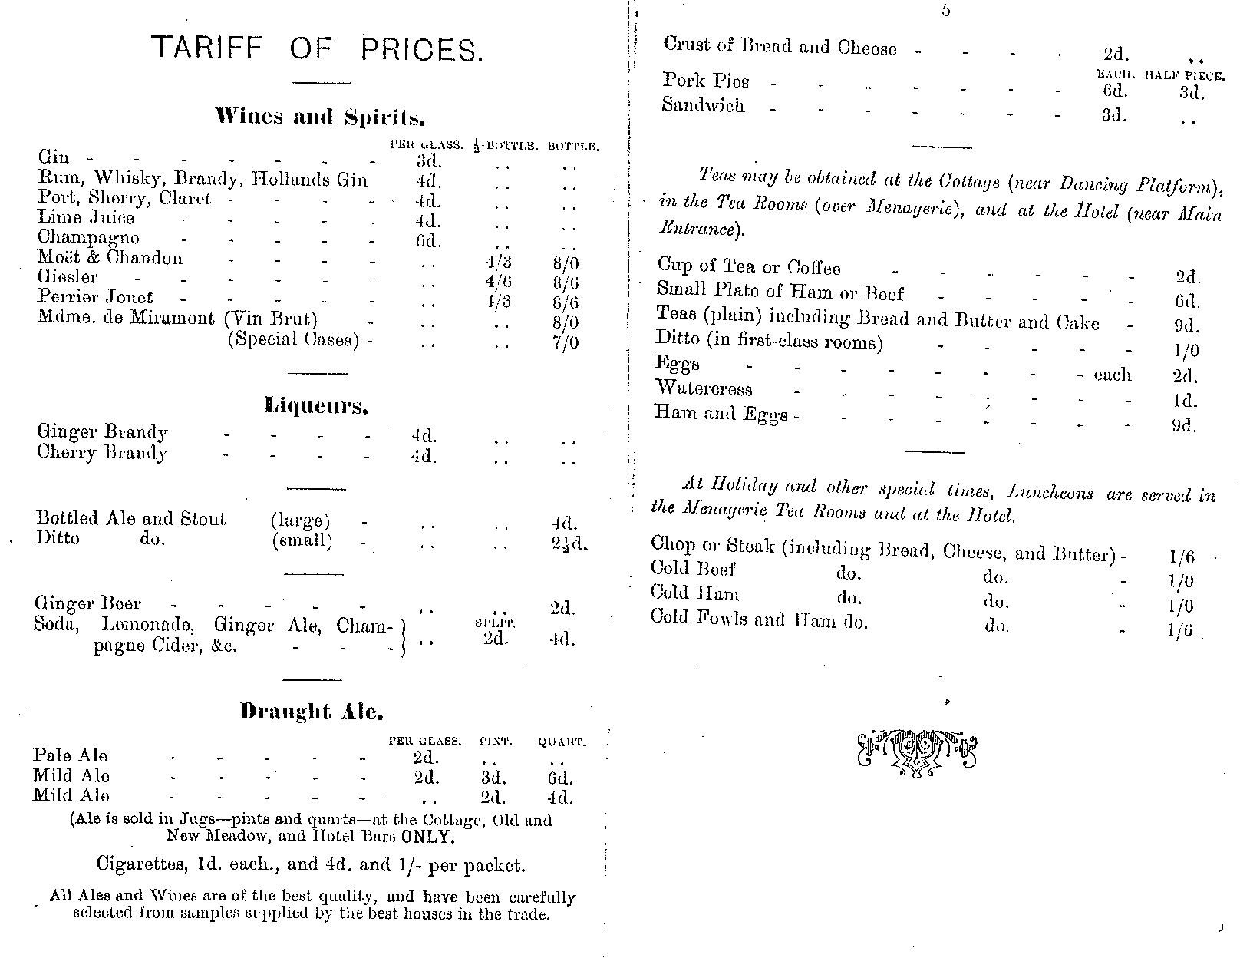
The price list for refreshments at the RustIc Cottage, Lower Grounds
There was also, most innovatively a facility for the manufacture of the sites very own
mineral water. Set up in 1876, it continued to produce its wares right up to, it seems the 1890s, when it would appear to have fallen prey to cutbacks.

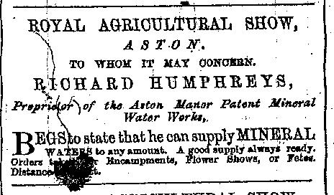

Advertisement placed in the Birmingham and Aston Chronicle 1876

Located near to the Menagerie the plant was capable of providing for some 12,000 units of aerated water per day, thus making, it seems, the site self sufficient in this most useful commodity.
However, for the sporting enthusiast the site also offered commendable facilities. The area which had been allocated for this purpose which was known as The Cricket and Football Meadow covered some eight acres, and was described as having a surface as ’level as a billiard table.’ Additionally this area was also blessed with a cycling and running track. This latter facility, comprising of a surface of cinder, equating to a distance of 501 yards had corners ‘rounded so as to reduce the risk of accidents to a minimum’. This, as will be indicated later in chapter five was the scene upon which many notable sporting events were performed and which perhaps more than any other attraction made the Lower Grounds famous, both locally and nationally
Given that all of these facilities were contained within ornamental gardens and parkland which had tree lined avenues introduced for strolling and, perhaps most innovatively fitted with electrical lighting so as to enable evening entertainment clearly made the site an attractive and impressive venue. That it was also physically linked to a railway station at Witton Road, through a walkway, which in later years became a covered entrance, allowing for easy access and exit indicated that The Lower Grounds area certainly offered a most attractive character and potentially a most financially viable recreational site.
Yet, there are indications that the site was not financially strong. The Rates Book for Aston Manor shows for example that the company was in severe rates arrears, its rateable value being £1,250 at 1881. So, despite all the efforts made to provide a sound commercial recreational facility for the area The Aston Lower Grounds Company found itself in severe financial difficulties. The situation had indeed reached such a point that the creditors of the company thought it necessary to convene a meeting, under the presidency of Mr. Joseph Rowland, solicitor. This was, it would seem in order to settle the affairs of the company. Though it would appear that the company was valued over and beyond its liabilities, the figures being £157,620 and £98,477 it was the unsecured sum owned to creditors that was the major concern, this amounting to some £21,000. Though an amiable compromise was reached the site was financially doomed. Despite trading on for some three more years the position was essential intolerable and that by 1884 a formal repossession had taken place by Messrs. Wragge, Evans, Holliday and Godless and a new manager, Smith Reeves Jnr appointed to replace Mr. Quilter. It was a development that provided for the rather terse but accurate comment on the state of the site by Showell of: “The speculation did not appear to be successful.” That this situation had arisen was perhaps exacerbated, in part by the social unrest which became known as the ‘Aston Riots’ and the reputation that was thus bestowed upon the site.
This incident, which occurred in 1884 and, if a Mr. J. A. Bridges, JP can to be believed involved a considerable number of persons protesting against the Conservative Party. Inspiring, as it did assaults upon such luminaries as Sir Stafford Northcote and Lord Randolph Churchill it led to the final removal of the pretence of the Lower Grounds being a site of ‘respectable and fashionable leisure’. It was later rumoured that the whole affair had been stage-managed by the Radicals who were angry at the discussions that were proceeding in regards to a Franchise Bill. Whatever the cause, the Spectator Magazine was driven to make the comment that a political meeting has been cast into disarray in a manner ‘commonly seen earlier in the century.’ Whether or not this incident did have a direct effect upon the performance of the site might be queried but the fact that the site was, at this time in an ever increasingly difficult financial position. In what must have been an attempt to economise, in 1886 the Theatre closed, though it did open again within a relatively short time. However the standard of presentation that was presented from this time, in many ways fell away sharply. Perhaps a good example of this decline can be perceived when it is noted that in August of 1887, a month when normally the extravagant Bank Holiday attractions would be offered the venue provided the following attractions, Professor Peterson’s Performing Dogs, Captain Dixon’s Rifle Shooting, and perhaps as an antidote to these, rather mundane attractions four military bands. It is not to say however that as finance and opportunity permitted the management did not attempt to uphold the traditional standard of presentation. However, in recognising the changing trends in theatre presentation they now, at times presented theatre from within the Burlesque tradition. For, in addition to the features already indicated there was a short play ‘Don Giovanni Junior - Fun at the Opera.’
Yet amazingly, despite what must be seen as an atmosphere of financial inadequacy it seems that the management decided to introduce what must have been thought of as, one last ‘sensational’ item. In 1887 it announced that a new attraction, a ‘Switchback Railway’ would be available for the enjoyment of the customer. Said to have been built on the same scale as the railway which was a feature of the American Exhibition of 1887, in London it can perhaps best be said to have been an early Roller Coaster. Though no documentation exists that adequately describes it, the press chose to depict it as: “being on the same scale as the railway which was seen at the American Exhibition in London.” If this can be considered accurate then it must have been similar to a creation that was first introduced to Coney Island, New York. Unfortunately it would appear that though it was certainly constructed no evidence is available as to its use. What is known however is that it was situated near the Bevington Road entrance and that three men were injured by falling timber when it was dismantled on 25th September, 1888.
Despite this effort the situation had reached such a position that by 1901 it was realised that it was difficult for the company to continue to trade. Sadly despite these valiant efforts to sustain the company the final coup de gras was delivered when the site was purchased by Flowers & Son, a large property company. That such a situation could have been arrived at was fundamentally due to the fact that, as a commercial enterprise it had been unsuccessful in attracting sufficient numbers of customers to enable it to attain a stable financial position. It had also seemingly failed to have recognized that there was evolving a changing landscape of recreational requirements. Recreation had, from the 1870s become ever increasingly, as chapter 7 will indicate, more diverse. Though The Lower Grounds site could still provide entertainment it was not, as the years passed sufficiently attractive enough to sustain the company in the face of the alternatives that were constantly being presented. That such a situation could have arisen can perhaps be identified not only as a result of misplaced ambition but also, and perhaps more importantly, the emergence of factors that the company could do little about, the development of private recreational organisation and of a broader, more diverse recreational landscape.
As a result of this decline the facility finally failed, the site being eventually sub-divided into lots for lease/purchase, allowing, amongst others Aston Villa FC, in 1892 to initially lease and then purchase a substantial part of it. This enabled this ever ambitious and successful club to move from Wellington Road, Perry Barr to their spiritual home, Aston Manor, draining the location that was previously the lake. This area which was situated on the land between Witton Road and Trinity Road, enabled the club finally in 1897 to establish a stadium that has gloried in the name of Villa Park ever since as its permanent home.

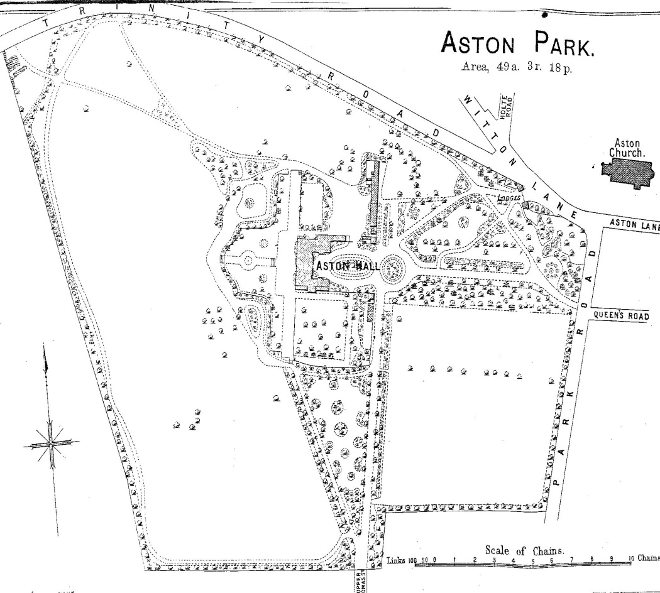

Aston Park, as at 1892
However, the remaining site still continued to present entertainment, though this was now of a rather staid nature. It appears, if the advertisements that were placed in the local press are to be believed what was presented might best be termed as light opera, with a single artist accompanied by a local band. Nevertheless it still appears that sometimes quite reasonable sized audiences attended. One such event was when a Mr. Tom Griffiths of The J. W. Turner Opera Company sang a selection of works by Gounad. Additionally, he also provided a new rendition of ‘Abide With Me’, which, for one individual in the audience must have been particularly interesting, this being Mr. S. Bradsworth, the actual composer of the piece. Yet even now, with the site quite clearly reduced in size, with much of its former facilities not available what remained still faced difficulties. Now it was the Temperance Movement that presented itself as the danger to its existence.
Indeed, from the very time of the conception of the site as a recreational facility this movement had saw fit to demand, if not the actual removal of the facility, at least the selling of alcohol within it. Now at the very time when the site has found itself in strained circumstances it chose to renew its attack. In demanding that the Music Licence of the Lower Grounds be removed it saw the very real possibility that they could actually rid the area of the site. Now, however it was the press who came to the rescue. In stating that though they recognised the value of temperance The Aston Times, amongst others made it plainly clear that they considered such a demand inappropriate. The newspaper clearly believed that the basis for this demand was weak and that the:

“Temperance ticket would not carry sufficient weight and that the grounds of objection to the place must be based on the opportunities for vice the concerts afforded the large numbers of young people who frequented the Grounds.”

Despite the fact that the objectors were perceived as men of principle the press considered that the aim they had set out to achieve did not have enough merit. Happily the demand was rejected and as far as can be ascertained never resurrected. Indeed it would seem that the Temperance Movement of Aston Manor, from this time onwards never again found the strength or opportunity to confront the park facility again.
Sadly the successful repelling of the threat to its music provision could not prevent further decline. The cost of maintaining the grounds and the various buildings was, in this situation prohibitive and perhaps, with the realization that little else could be done The Aston Lower Ground site, in 1902 finally closed. The removal of the buildings was then inevitable. Indeed by 1904 what remained of the facilities that once graced the site were in such poor condition that it must have been realised that they were beyond saving. Certainly, a Mrs. Chilton, who now owned what previously had been the dancing pavilion certainly might have been able to testify to this fact. For, when she and some of her friends were enjoying a moment of relaxation on the green, in close proximity to what remained of it, the whole wooden structure, suddenly and without warning collapsed. Happily there were no injuries.
By 1911 all had been removed, all except the original Aquarium/Menagerie building which, according to the Aston Rates Book of 1911 was in the process of being converted by the rapidly expanding Aston Villa FC into offices. The once much admired recreational facility of The Lower Grounds of Aston Manor had thus ceased to exist. Its demise however did present both Aston Manor and her neighbour Birmingham with a problem. The question to be answered now was: Who now was to take responsibility for the Hall and its parkland? It would seem that at last the Birmingham Council had accepted that it was accountable and that the situation had clearly been reached when something needed to be done to retain it as a recreational facility. After what appears to have been a heated discussion between the Council and those of Aston Manor, in 1904 a compromise was reached which as a result provided the Manor with the responsibility of contributing half of the total costs. It would seem that even at this late stage Birmingham was reluctant to accept full financial responsibility. This arrangement, it would seem remained in operation until it was made redundant through the annexation of the Manor into Birmingham in the November of 1911, forcing the City had to take full responsibility for the whole site.
However this demise did not signal a total removal of recreational presentations. Though still retaining the name of the Lower Grounds it along with the remainder of the parkland continued, as the next chapter will indicate, to be a site However this demise did not signal a total removal of recreational presentations. Though still retaining the name of the Lower Grounds it along with the remainder of the parkland continued, as the next chapter will indicate, to be a site that was the scene of much activity. Football and cricket, for example still continued to be played, though now the crowds had virtually disappeared, due in no small way to the presence, from 1892 of Aston Villa FC, this club already having established itself as a force within the national game. Drawing crowds to fixtures held both on what was the Lower Ground and later at their custom built stadium they were of such a magnitude that the various managers of the companies that had run the Lower Grounds site could only have dreamed of. It was this club which now occupied, for many the imagination of Aston and one which has since come to the represent the location which has developed since absorption.
Yet, even within what might be termed its ‘death throes’ the Lower Grounds could still surprise. It would seem that those individuals empowered by the Council of Birmingham to oversee its running must have still imagined that salvation or at least some form of financial restitution could still be obtained. It was perhaps within this ideal that, as will be indicated in chapter six, perhaps drawing upon the tradition of the spectacular the famous Buffalo Bill and his Wild West Show was presented. It was this final flourish which effectively signalled the end. After this there was nothing but decline until nothing remained but memories of a site that had, during its time provided so much pleasure and excitement.

Aston News, 21st May, 1904.
Aston Rate Book, vol 5, 1911, Birmingham Central Library.
Aston News, 27th February, 1904.

D. J. O’Neill, How Aston Hall and Park was Saved, p4, L50.13 Accession No. 222086.
J. A. Langford, Modern Birmingham and its Institutions vol 2, 1873, Birmingham: Birmingham Central Library, 1984, p131.
Aston Hall, Programme of the Grand Fete Champetre, in aid of The Queens Hospital, 28th July, 1856. L50.13 Accession No. 64466.
City of Birmingham public Parks and Pleasure Grounds, 1892, Birmingham: Birmingham Corporation.
J. A. Langford, Modern Birmingham and its Institutions vol 2, 1873, Birmingham: Birmingham Central Library, 1984, pp133-134.
J. A. Langford, Modern Birmingham and its Institutions vol 2, 1873, Birmingham: Birmingham Central Library, 1984, pp135-136.
Aston Hall and Company Limited, Memorandum and Articles of Association with two shareholders tickets, 1858. Birmingham Institutions G/5, Accession No. 247455.
J. A. Langford, Modern Birmingham and its Institutions vol 2, 1973, Birmingham: Birmingham Central Library, 1984, pp143.
J. A. Langford, Modern Birmingham and its Institutions vol 2, 1973, Birmingham: Birmingham Central Library, 1984, pp138.
T. Woollaston, ‘Experiences and Recollections of occurrences on the occasion of the opening of Aston Hall and Park’ in Police Experiences and Reminiscences of Official Life, 1984. SOS Accession No. 266420.
D. J. O’Neill, How Aston Hall and Park was Saved, p43., L50.13 Accession No. 222086.
Queen Victoria’s visit to Birmingham, June 15th, 1858. Dejeuner at Aston Hall .Menu printed on Satin, 1858. Map drawer 338, Misc. S/1, Accession No. 333857.
J. A. Langford, Modern Birmingham and its Institutions vol 2, 1873, Birmingham: Birmingham Central Library, 1984, pp142.
J. A. Langford, Modern Birmingham and its Institutions vol 2, 1873 Birmingham: Birmingham Central Library, 1984, pp143.
For a drawing of Aston Hall and Park that was intended to be a gift to the Queen but had not been accepted see A. E. Everitt, reproduced by Birmingham Public Libraries Photostat copy, 1939. Miscellaneous W/2 SE3, Accession No. 437576.
D. J. O’Neill, How Aston Hall and Park was Saved, pp25-28, L50.13 Accession No. 222086.
Strong, R., The Spirit of Britain, Great Britain: Hutchinson, 1999, chp. 32, p523.
W. Showell., Showells Dictionary of Birmingham, England: Walter Showell & Sons, 1885. See W. C. Atkins, Official Guide to Aston Hall, Exhibition of Fine Arts, 1858, SC3, Accession. No. 259267.
D. J. O’Neill, How Aston Hall and Park was Saved, p43., L50.13 Accession No. 222086.
Windows on Warwickshire, www.search.windowsonwarwickshire.org.
See Chapter 3, page p92 for an example of another contribution from this author.
Quiz, Aston Hall and Park: The Queens visit to Birmingham. A playful reminiscence of that great event in random rhyme, Birmingham: William Cornish’s Royal Library, 1858. Birmingham: William Cornish Royal Library, 1858. Lp22.3 Accession. No. 64730. This is copied using the exact spelling as in the original article.
Aston Hall and Park Company, Report and Balance Sheet of The Colossal Fete presented by the Canvassing Committee to the Shareholders, 1859. Lp50.13 Accession No. 64468.
Aston Hall and Park Company. Limited. Report of The Investigative Committee, 1860, p30. Birmingham Institutions D/15 Accession No. 66244.
The London Times, 18th September, 1861, p12.
For a report on the magistrates court which tried those arrested see The London Times, 20th September, 1981, p5.
This is a bowl, generally made of wood and often mounted in silver, used on ceremonial occasions for drinking toasts. The word wassail derives from Old Norse ves heill, meaning “be well, and in good health.” The name has come to be generally applied to any bowl from which a toast is drunk, as well as to the actual drink itself.
The original way in which the term was spelt, it was this version which was used in the programme for the event. For a history of the tradition see J. Brand & Sir H. Ellis, The Popular Antiquities of Great Britain" London: Reeves and Turner, 1905. Vol. 2.
Annual Christmas Festivities at Aston Hall 1861-1862, L50.18 Acc. No. 279716.
For information as to the history of this female see F. Thomas, Circus Life and Circus Celebrities, London: Chatto and Windus, 1881, chp 9.
For an account of the tragedy, see the 22nd July, 1863 issue of The London Times London: Times of London, 1863.
The New York Times, 4th August, 1863
J. A. Langford, Modern Birmingham and its Institutions vol. 2, 1873 Birmingham: Birmingham Central Library, 1984, pp155.
A further six acres were purchased in 1873 at an additional cost of £4,750, providing a total area of about 10 acres.Even as late as 1876 there were still portions of land for sale. To see an advertisement see The Aston & Birmingham Chronicle, 2nd September 1876.
The drawing of the this gentleman can be found in the 28th February, 1880 issue of The Dart, vol 4, Birmingham: John Boucher, 1880, p5.
D. J. O’Neill, How Aston Hall and Park was Saved, p43. L50.13 Accession No. 22086.
For a very brief summary of this gentleman’s life see the 28th February, 1880 issue of The Dart, vol 4, Birmingham: John Boucher, 1880.
Birmingham and Aston Chronicle, 20th May, 1876.
Post Office Directory of Birmingham, London: Post Office Publishing, May, 1871.
Now part of the Covent Garden complex, London.
In 1876 a William Brown of Birmingham patented a design for the wheels of roller skates. Brown worked closely with a Joseph Henry Hughes, who drew up the patent for a ball or roller bearing race for bicycle and carriage wheels in 1877.These two men are generally considered responsible for modern day roller skate. For a history of the roller skate see www.rollersports.ca/roller-sports/history.com,
Aston and Birmingham Chronicle, 18th December, 1875.
Aston Lower Grounds, Descriptive Guide, The Skating Rink, L27.2 Accession No. 28546, 1886.
H. G. Quilter, The Skating Rink, Lower Grounds, Birmingham. Scale of Charges, rules and reputations, Lp27.2 Accession No. 284574, 1878.
Birmingham and Aston Chronicle, 3rd February, 1877.
Kelly’s Directory of Birmingham, London: Kelly & Co., Printers, 1880.
Aston Lower Grounds Descriptive Guide, The Skating Rink, 1876,L27.2 Accession No. 28546.
Aston Observer and Handsworth Times, 6th September, 1879.
The Daily Gazette, 22nd August, 1884
Aston Lower Ground Guide, 1884, in Hammonds Illustrated Guide, Aston Lower Grounds 1882-1887, Birmingham: Hammond Co. Ltd, p13.
It should always be remembered that many of the working class sought and attained what the era perceived as ‘respectability.’ Those of the Temperance Movements and of the Artisan class being only two examples.
Aston Lower Ground Guide 1887, in Hammonds Illustrated Guide, Aston Lower Grounds 1882-1887, Birmingham: Hammond Co. Ltd, p13. Also see W. Showell, Showell’s Dictionary of Birmingham, England: Walter Showell & Sons, 1885.
Kelly’s Directory of Birmingham, London: Kelly & Co., Printers, 1880.
Aston Lower Ground Guide 1887, in Hammonds Illustrated Guide, Aston Lower Grounds 1887, Birmingham: Hammond Co. Ltd, p14.
Birmingham and Aston Chronicle, 9th April, 1887.
Aston Lower Ground Guide 1887, in Hammonds Illustrated Guide, Aston Lower Grounds 1887, Birmingham: Hammond Co. Ltd., p13.
Aston Lower Ground Guide 1887, in Hammonds Illustrated Guide, Aston Lower Grounds 1882-1887, Birmingham: Hammond Co. Ltd.
Aston Lower Ground Guide 1887, in Hammonds Illustrated Guide, Aston Lower Grounds 1882-1887, Birmingham: Hammond Co. Ltd.
Birmingham and Aston Chronicle, 2nd September, 1876.
Aston Lower Ground Guide 1887, in Hammonds Illustrated Guide, Aston Lower Grounds 1882, Birmingham: Hammond Co. Ltd., p23.
See Chapter 1.
Aston Rates Book, volume 3, 1881.
Aston Observer and Handsworth Times, 17th April, 1880.
Showells Dictionary of Birmingham, 1888.
J. A. Bridges, Reminiscences of a County Politician, London: T. Werner, 1906, chp 12.
The Spectator Magazine, 18th October, 1884.
Birmingham and Aston Chronicle, 6th August, 1887.
Birmingham and Aston Chronicle, 19th November, 1887.
Birmingham and Aston Chronicle, 19th November, 1887.
Coney Island, http://history.amusement-parks.com/coneycoasters.htm
N. Williams, The Birmingham Onion Fair, England: Uralia Press, 2001, p17.
City of Birmingham, Public Parks and Pleasure Grounds, 1892, Birmingham: Birmingham Library Services. Note: The location of Aston Villa FC’s stadium is located in the area formed by the junction of Trinity Road and Witton Lane.
Aston News, 21st May, 1904.
Birmingham and Aston Chronicle, 21st May, 1904.
Aston Times, 25th August, 1894.
Aston News, 21st May, 1904.
Aston Rate Book, vol 5, 1911, Birmingham Central Library.
Aston News, 27th February, 1904.

